Linux Task Documentation – File Ownership & Permissions

Date: 9 February 2026
Objective:
The objective of this task was to understand Linux file ownership, group ownership, permission errors, and how to resolve them using sudo privileges.

Environment:
- OS: Linux (Ubuntu / WSL)
- Terminal: Bash
- Users involved: bob, shariqua
- Group involved: testgroup

Task Summary:
- Created a file using a normal user
- Faced permission denied error while changing ownership
- Used sudo to change file owner and group
- Verified file ownership and permissions
- Applied secure permission settings

Steps Performed:
1. Created a File:
touch report.txt
2. Checked File Details:
ls -l

Output:
-rw-rw-r-- 1 bob bob report.txt

3. Attempted to Change Ownership (Failed):
chown shariqua report.txt

Error:
Operation not permitted

4. Changed Ownership Using sudo:
sudo chown shariqua report.txt

5. Verified Ownership:
ls -l

Output:
-rw-rw-r-- 1 shariqua bob report.txt

6. Changed Group Ownership:
sudo chown :testgroup report.txt

7. Verified Group Change:
ls -l

Output:
-rw-rw-r-- 1 shariqua testgroup report.txt

8. Changed File Permissions:
sudo chmod 640 report.txt

9. Final Permission Check:
ls -l

Final Output:
-rw-r----- 1 shariqua testgroup report.txt

Permission Explanation:
6 = Read + Write (Owner)
4 = Read only (Group)
0 = No access (Others)
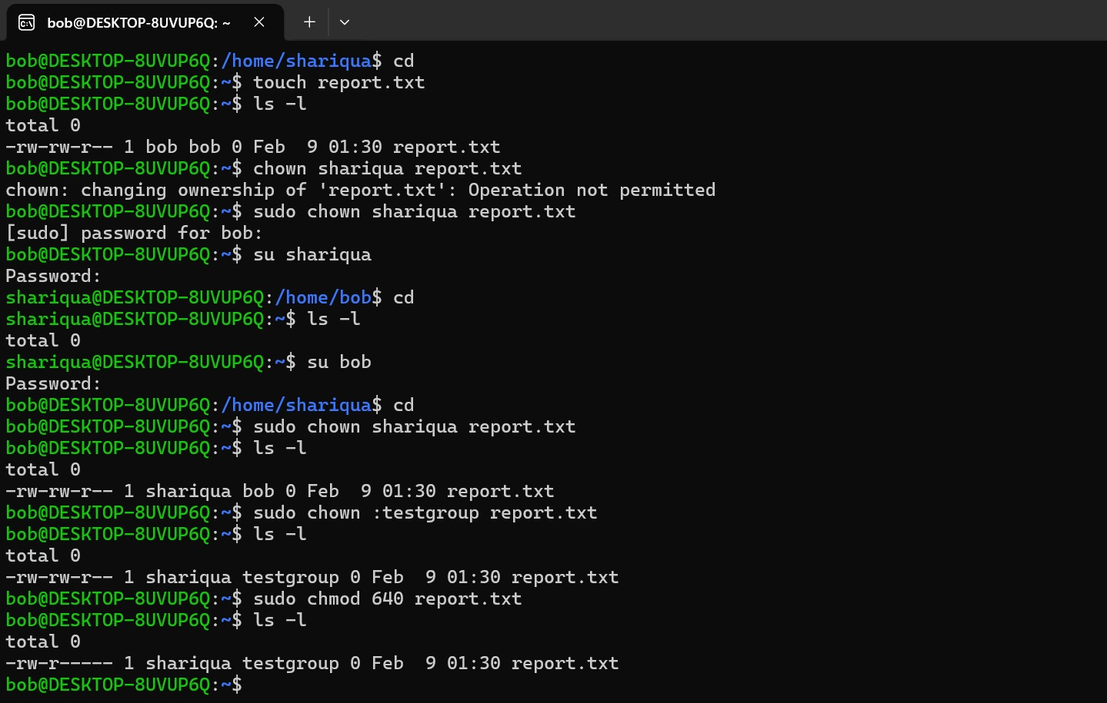

Conclusion:
This task demonstrates practical handling of Linux file ownership, group management, permission errors, and secure access control using sudo.

Author:
Shariqua Waseem

